Introduction:
A three phase transformer can be constructed either by connecting together three single-phase transformers called three phase transformer bank, or by using one pre-assembled and balanced three phase transformer which consists of three pairs of single phase windings mounted on one single laminated core.
The advantages of a single unit three phase transformer when compare with three single phase transformers bank for the same kVA rating are 1) small in size 2) lighter in weight 3) cheap in cost.
The primary windings are connected in one of several ways. The two most common configurations are the delta, in which the polarity end of one winding is connected to the non-polarity end of the next, and the star, in which all three non-polarities (or polarity) ends are connected together. The secondary windings are connected similarly. This means that a 3-phase transformer can have its primary and secondary windings connected the same (delta-delta or star-star), or differently (delta-star or star-delta).
It’s important to remember that the secondary voltage waveforms are in phase with the primary waveforms when the primary and secondary windings are connected the same way. This condition is called “no phase shift.” But when the primary and secondary windings are connected differently, the secondary voltage waveforms will differ from the corresponding primary voltage waveforms by 30 electrical degrees. This is called a 30 degree phase shift. When two transformers are connected in parallel, their phase shifts must be identical; if not, a short circuit will occur when the transformers are energized.”

Winding connection designations:
First Symbol:
For High Voltage: Always capital letters.
D=Delta, Y=Star, Z=Interconnected star, N=Neutral
Second Symbol:
For Low voltage: Always Small letters.
d=Delta, y=Star, z=Interconnected star, n=Neutral.
Third Symbol:
Phase displacement expressed as the clock hour number (0, 1, 6, and 11)
Example – Dyn11
Transformer has a delta connected primary winding (D) a star connected secondary (y) with the star point brought out (n) and a phase shift of 30 deg leading (11).

Vector Group of Transformer:
The three phase transformer windings can be connected several ways. Based on the windings’ connection, the vector group of the transformer is determined.
The transformer vector group is indicated on the Name Plate of transformer by the manufacturer.
The vector group indicates the phase difference between the primary and secondary sides, introduced due to that particular configuration of transformer windings connection.
The Determination of vector group of transformers is very important before connecting two or more transformers in parallel. If two transformers of different vector groups are connected in parallel then phase difference exist between the secondary of the transformers and large circulating current flows between the two transformers which is very detrimental.

Phase Displacement between HV and LV Windings:
- The vector for the high voltage winding is taken as the reference vector. Displacement of the vectors of other windings from the reference vector, with anticlockwise rotation, is represented by the use of clock hour figure.
- Symbol for the high voltage winding comes first, followed by the symbols of windings in diminishing sequence of voltage. For example a 220/66/11 kV Transformer connected star, star and delta and vectors of 66 and 11 kV windings having phase displacement of 0° and -330° with the reference (220 kV) vector will be represented As Yy0 – Yd11.
- The digits (0, 1, 11 etc) relate to the phase displacement between the HV and LV windings using a clock face notation. The phasor representing the HV winding is taken as reference and set at 12 o’clock. Phase rotation is always anti-clockwise. (International adopted).
- Use the hour indicator as the indicating phase displacement angle. Because there are 12 hours on a clock, and a circle consists out of 360°, each hour represents 30°.Thus 1 = 30°, 2 = 60°, 3 = 90°, 6 = 180° and 12 = 0° or 360°.
- The minute hand is set on 12 o’clock and replaces the line to neutral voltage (sometimes imaginary) of the HV winding. This position is always the reference point.
Example:
  - Digit 0 =0° that the LV phasor is in phase with the HV phasor
  - Digit 1 =30° lagging (LV lags HV with 30°)
  - Digit 11 = 330° lagging or 30° leading (LV leads HV with 30°)
  - Digit 5 = 150° lagging (LV lags HV with 150°)
  - Digit 6 = 180° lagging (LV lags HV with 180°)

- When transformers are operated in parallel it is important that any phase shift is the same through each. Paralleling typically occurs when transformers are located at one site and connected to a common bus bar (banked) or located at different sites with the secondary terminals connected via distribution or transmission circuits consisting of cables and overhead lines.

Phase Shift (Deg) | Connection
0 | Yy0 | Dd0 | Dz0
30 lag | Yd1 | Dy1 | Yz1
60 lag |  | Dd2 | Dz2
120 lag |  | Dd4 | Dz4
150 lag | Yd5 | Dy5 | Yz5
180 lag | Yy6 | Dd6 | Dz6
150 lead | Yd7 | Dy7 | Yz7
120 lead |  | Dd8 | Dz8
60 lead |  | Dd10 | Dz10
30 lead | Yd11 | Dy11 | Yz11

- The phase-bushings on a three phase transformer are marked as ABC, UVW or 123 (HV-side capital, LV-side small letters). Two winding, three phase transformers can be divided into four main categories (Groups)

Group | O’clock | TC
Group I | 0 o’clock, 0° | delta/delta, star/star
Group II | 6 o’clock, 180° | delta/delta, star/star
Group III | 1 o’clock, -30° | star/delta, delta/star
Group IV | 11 o’clock, +30° | star/delta, delta/star
Minus indicates LV lagging HV, plus indicates LV leading HV

Clock Notation: 0

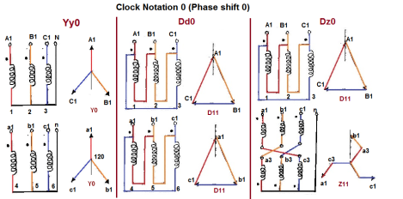

Clock Notation: 1

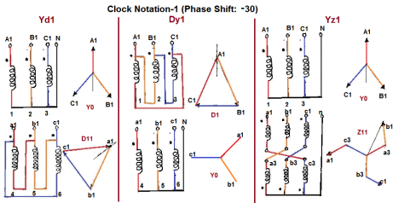

Clock Notation: 6

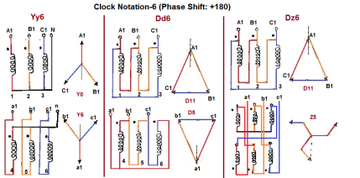

Clock Notation: 11

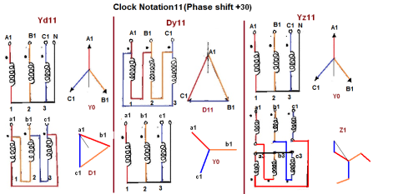

Points to be consider while Selecting of Vector Group:
- Vector Groups are the IEC method of categorizing the primary and secondary winding configurations of 3-phase transformers. Windings can be connected as delta, star, or interconnected-star (zigzag). Winding polarity is also important, since reversing the connections across a set of windings affects the phase-shift between primary and secondary. Vector groups identify the winding connections and polarities of the primary and secondary. From a vector group one can determine the phase-shift between primary and secondary.
- Transformer vector group depends upon
  - Removing harmonics: Dy connection – y winding nullifies 3rd harmonics, preventing it to be reflected on delta side.
  - Parallel operations: All the transformers should have same vector group & polarity of the winding.
  - Earth fault Relay: A Dd transformer does not have neutral. to restrict the earth faults in such systems, we may use zig zag wound transformer to create a neutral along with the earth fault relay..
  - Type of Non Liner Load: systems having different types of harmonics & non linear Types of loads e.g. furnace heaters ,VFDS etc for that we may use Dyn11, Dyn21, Dyn31 configuration, wherein, 30 deg. shifts of voltages nullifies the 3rd harmonics to zero in the supply system.

Application of Transformer according to Vector Group:

(1) (Dyn11, Dyn1, Ynd1, Ynd11)
- Common for distribution transformers.
- Normally Dyn11 vector group using at distribution system. Because Generating Transformer are YNd1 for neutralizing the load angle between 11 and 1.
- We can use Dyn1 at distribution system, when we are using Generator Transformer are YNd11.
- In some industries 6 pulse electric drives are using due to this 5thharmonics will generate if we use Dyn1 it will be suppress the 5th harmonics.
- Star point facilitates mixed loading of three phase and single phase consumer connections.
- The delta winding carry third harmonics and stabilizes star point potential.
- A delta-Star connection is used for step-up generating stations. If HV winding is star connected there will be saving in cost of insulation.
- But delta connected HV winding is common in distribution network, for feeding motors and lighting loads from LV side.

(2) Star-Star (Yy0 or Yy6)
- Mainly used for large system tie-up Transformer.
- Most economical connection in HV power system to interconnect between two delta systems and to provide neutral for grounding both of them.
- Tertiary winding stabilizes the neutral conditions. In star connected transformers, load can be connected between line and neutral, only if
- The source side transformers is delta connected or
(b) The source side is star connected with neutral connected back to the source neutral.
- In This Transformers. Insulation cost is highly reduced. Neutral wire can permit mixed loading.
- Triple harmonics are absent in the lines. These triple harmonic currents cannot flow, unless there is a neutral wire. This connection produces oscillating neutral.
- Three phase shell type units have large triple harmonic phase voltage. However three phase core type transformers work satisfactorily.
- A tertiary mesh connected winding may be required to stabilize the oscillating neutral due to third harmonics in three phase banks.

(3) Delta – Delta (Dd 0 or Dd 6)
- This is an economical connection for large low voltage transformers.
- Large unbalance of load can be met without difficulty.
- Delta permits a circulating path for triple harmonics thus attenuates the same.
- It is possible to operate with one transformer removed in open delta or” V” connection meeting 58 percent of the balanced load.
- Three phase units cannot have this facility. Mixed single phase loading is not possible due to the absence of neutral.

(4) Star-Zig-zag or Delta-Zig-zag (Yz or Dz)
- These connections are employed where delta connections are weak. Interconnection of phases in zigzag winding effects a reduction of third harmonic voltages and at the same time permits unbalanced loading.
- This connection may be used with either delta connected or star connected winding either for step-up or step-down transformers. In either case, the zigzag winding produces the same angular displacement as a delta winding, and at the same time provides a neutral for earthing purposes.
- The amount of copper required from a zigzag winding in 15% more than a corresponding star or delta winding. This is extensively used for earthing transformer.
- Due to zigzag connection (interconnection between phases), third harmonic voltages are reduced. It also allows unbalanced loading. The zigzag connection is employed for LV winding. For a given total voltage per phase, the zigzag side requires 15% more turns as compared to normal phase connection. In cases where delta connections are weak due to large number of turns and small cross sections, then zigzag star connection is preferred. It is also used in rectifiers.

Application of Transformer according according to Uses:
- Step up Transformer: It should be Yd1 or Yd11.
- Step down Transformer: It should be Dy1 or Dy11.
- Grounding purpose Transformer: It should be Yz1 or Dz11.
- Distribution Transformer: We can consider vector group of Dzn0 which reduce the 75% of harmonics in secondary side.
- Power Transformer: Vector group is deepen on application for Example: Generating Transformer: Dyn1, Furnace Transformer: Ynyn0.

Open Delta or V-V Connection of 3-Phase Transformer
As seen previously in connection of three single phase transformers that if one of the transformers is unable to operate then the supply to the load can be continued with the remaining tow transformers at the cost of reduced efficiency. The connection that obtained is called V-V connection or open delta connection.
Consider the Fig. 1 in which 3 phase supply is connected to the primaries. At the secondary side three equal three phase voltages will be available on no load.
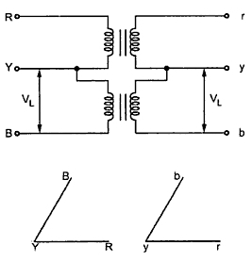
Fig. 1
The voltages are shown on phasor diagram. The connection is used when the three phase load is very small to warrant the installation of full three phase transformer.
If one of the transformers fails in ∆ - ∆ bank and if it is required to continue the supply even though at reduced capacity until the transformer which is removed from the bank is repaired or a new one is installed then this type of connection is most suitable.

Key point: It can be noted here that the removal of one of the transformers will not give the total load carried by V - V bank as two third of the capacity of ∆ - ∆ bank.

The load that can be carried by V - V bank is only 57.7% of it. It can be proved as follows.
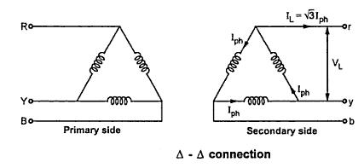
Fig. 2(a)
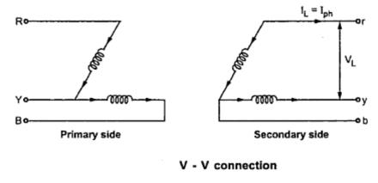
Fig. 2(b)

It can be seen from the Fig. 2(a)
∆ - ∆ capacity = √3 V_{L} I_{L} = √3 V_{L} (√3 I_{ph})
∆ - ∆ capacity = 3 V_{L} I_{ph} ............ (i)
It can also be noted from the Fig. 2(b) that the secondary line current I_{L} is equal to the phase current I_{ph}.
V- V capacity = √3 V_{L} I_{L} = √3 V_{L} I_{ph} ...............(ii)
Dividing equation (ii) by equation (i)
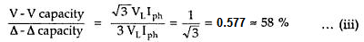

Thus the three phase load that can be carried without exceeding the ratings of the transformers is 57.5 percent of the original load. Hence it is not 66.7 % which was expected.

The reduction in the rating can be calculated as
{(66.67 - 57.735)/ (57.735)} x 100 = 15.476%

Suppose that we consider three transformers connected in ∆ - ∆ fashion and supplying their rated load. Now one transformer is removed then each of the remaining two transformers will be overloaded. The overload on each transformer will be given as,
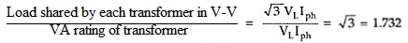

Key point: This overload can be carried temporarily if provision is made to reduce the load otherwise overheating and breakdown of the remaining two transformers would take place.

Limitations
The limitations with V -V connection are given below:
- The two transformers in V -V bank operate at different power factor except for balanced unity p.f .load.
- The terminals voltages available on the secondary side become unbalanced. This may happen even though load is perfectly balanced.
- If a bank of two single phase transformers connected in V-V fashion supplying a balanced three phase load with power factor cosΦ. The two transformers operate at two different power factors. One of the transformers operate at a pf of cos (30-Φ) and other at cos (30+Φ).

The powers of two transformers are given by,
P₁ = KVA cos (30-Φ) and P2 = KVA cos (30+Φ)
- If ∆ - ∆ fashion and supplying their rated load. Now one transformer is removed then each of the remaining two transformers will be overloaded by 73.2 %.
- Utilization factor of V-V bank,
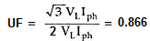

Example:
A ∆ -∆ bank consisting of three 40 KVA, 2300/230 V transformers supplies a load of 80 KVA. If one transformer is removed, find for the resulting V - V connection
  - KVA load carried by each transformer
  - percent of rated load carried by each transformer
  - total KVA rating of the V - V bank
  - ratio of the V - V bank to ∆ - ∆ bank transformer ratings
  - Percent increase in load on each transformer when bank is converted into V - V bank.

Conversion from Three Phase to Tow phase (Scott Connection or T-T connection)
With the help of Scott connection, proposed by C.F. Scott, it is possible to obtain 2-phase supply which is required for furnaces or even three phase load can be driven from the available 2-phase supply source. The Scott connection which is serving this purpose is shown in the Fig.1.

This connection requires two transformers. One of the transformers having 50% taping in primary winding and one secondary winding is called main transformer and other one having 86.6% tapping in primary and one secondary is called teaser transformer. The connection diagram of Scott connection is as shown in the Fig. 1.

One end of the primary winding of the teaser transformer is connected to the centre tapping provided on the primary winding of the main transformer. The two end of the primary winding of the main transformer and 86.6 tapping point on the teaser transformer is connected to a balanced three phase supply. The voltage per turn is same both in primary of both main and teaser transformers. With the equal number of turns on Secondaries of both the transformers, the secondary voltage will be equal in magnitude which results in symmetrical 2-phase system.

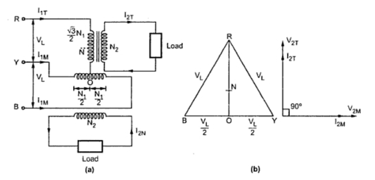
Fig. 1
The main transformer primary winding consists of N₁ turns connected between lines Y and B of a symmetrical three phase supply. V_{RY,} V_{YB} and V_{BR} are all line voltages. Hence V_{RY}= V_{YB} = V_{BR} = V_{L.} But RO being the altitude of the equilateral triangle, the voltage V_{RO} is (√3/2)V_{L}. The voltage per turn will be same in primaries of both the transformers if number of turns between R and O are (√3/2) N₁. With this then the terminal voltages on the secondary windings having same turns will be equal in magnitude and have a same difference of between them.
The point O is not the neutral point of 3 phase supply voltage as its voltage with respect to any line is not V_{L}/√3. N is the neutral point shown in Fig. 2. Voltage V_{RN} is nothing but V_{L}/√3 whereas V_{RO} is (√3/2) V_{L}. Hence the voltage between N and O will be
(√3/2)V_{L} - (1/√3) VL = 0.288 V_{L} ~ 0.29V_{L}
Since 0.29 is one third of 0.866, N divides the teaser winding RO in the ratio 2:1.

Relation between Input currents and output currents

Now let us consider the unity power factor load. The teaser secondary is supplying a current of I_{2T}. Neglecting the magnetizing current,
Transformation ratio, K_{T} = I_{1T}/I_{2T} = N₂ / (√3/2) N₁
Consider, I_{1T}/I_{2T} = N₂/ (√3/2) N₁
I_{1T} = I_{2T} x (N₂ / ((√3/2) N₁)) = (2/√3) (N₂/N₁) I_{2T}
=1.15 (N2/N₁) I_{2T}
... I_{1T} = 1.15 K I_{2T} .................. (i)
Each half on the primary winding of the main transformer carries current of consisting of I_{1m} two parts
.i) First part balances the main secondary current
I_{1M} = (N₂/N₁) I_{2M} = K I_{2M}
ii) The second part is equal to one half of the teaser primary current i.e. 0.5 I_{1T}
The main transformer primary winding forms a return path for the teaser primary current which is divided into two halves at point O in either direction.
The current in each half is equal to (I_{1T}/2) = ((1.15 K I_{2T}) /2) = 0.58 K I_{2T}
This current is shown in the Fig. 2

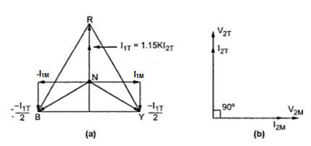
Fig. 2
Thus the phase R supplies current I_{1T} which is divided into equal parts and is flowing in the main transformer in the opposite directions. Thus the line currents on the primary side are vectorially given by,
Ī_{R} = Ī_{1T}
Ī_{Y} = Ī_{1M} - 0.5 Ī_{1T}
Ī_{B} = -Ī_{1M} - 0.5 Ī_{1T}
The magnitude of these line currents are given by,
I_{R} = I_{1T}
I_{Y} = I_{B} = √ ((I_{1M}) ² + (0.5 I_{1T}) ²)

The currents in the lines Y and B are obtained vectorially. The teaser transformer currents flowing in the two halves of the primary winding of the main transformer in the opposite direction and have no magnetic effect on the core and does not take part in balancing the secondary ampere turns of the main transformer. Thus when two phase load of unity power factor is balanced then three phase side is also balanced.

Now let us consider balanced two phase load at a lagging p.f. of cosΦ. The corresponding phasor diagram is shown in the Fig. 3. The three phase side is again balanced as the currents drawn from the three phase system are equal balanced and lag by angle Φ with respect to their respective phase voltages.

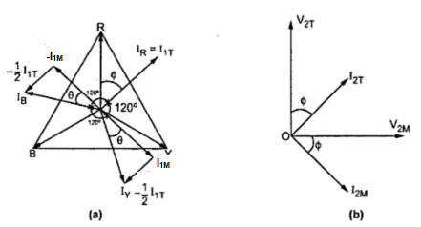
Fig. 3

Example 1: Two transformers are required for a Scott connection operating from a 415 V, 3 phase supply for supplying two single phase furnaces 225 V on the two phase side. If the total output is 150 KVA, calculate the secondary to primary turns ratio and the winding currents for each transformer.
Example 2: In a Scott connection, calculate the values of line currents on the three phase side, if the loads on 2 phase side are 300 kW and 400 kW, both at 125 V and 0.707 p.f. and the three phase line voltage is 3300 V. The 300 kW load is on the leading phase of the 2 phase side. Neglect the losses.

Testing of three phase transformers

  - Voltage Ratio Measurement
a) Purpose of the test
To determine
a. Any abnormality in tapings in the winding
b. Any abnormality in the winding
c. Result ensures the inductance property of the transformer
b) Principle of the Test
The total voltage induced into the secondary winding of a transformer is proportional to the number of turns in the primary to the number of turns in the secondary, and by the amount of voltage applied to the primary.

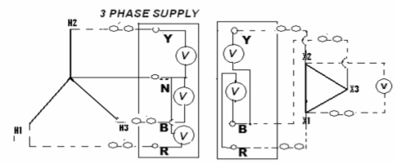

c) Procedure for the Test
1. Keep the tap position of the transformer in lowest position and LV in open
2. The voltage should be applied in the high voltage winding in order to avoid unsafe voltage
3. Apply 3 phase 415 V on HV terminals
4. Measure the voltage on each phase (ph-ph) on HV and LV terminals simultaneously.
5. Ratio measurement must be made on all the taps to confirm the proper alignment and operation of the tap changer.
6. Calculate the turns ratio in each tap position of tap: Vp/Vs

- Magnetizing Current Test

a) Purpose of the Test
Excitation/ Magnetizing current test is performed to locate defect in magnetic core structure, shifting of windings, failure in turn to turn insulation or problem in tap changer.

b) Principle of the Test
Excitation/ Magnetizing current is the current required to force a given flux through the core. It is the RMS value of the current flowing through a line terminal of a winding when voltage is applied at rated frequency, the other winding being open circuited.
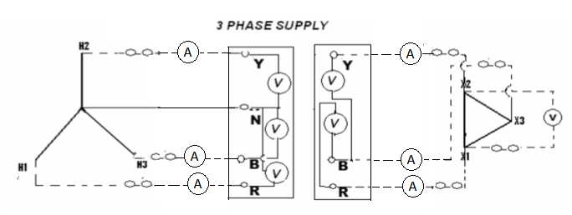

c) Procedure for the Test
1. Apply 3 phase 440 V AC supply on HV terminals and keep LV open.
2. Measure current in all the three phases.
3. Carry out the test on max., normal and min. tap position.
4. Repeat the test for LV side.

- Magnetic Balance Test

a) Purpose of the Test
To check the balance in the magnetic circuit (core balance) in three phase transformers. It verifies core balance.

b) Principle of the Test
The voltage should be applied in one phase and measured in the other two phase of the winding. The sharing of the voltage will be maximum in the next phase of the winding (clock wise) more than 60% of the injected voltage and minimum voltage appear in another phase of the winding (clock wise) less than 40% of the injected voltage.
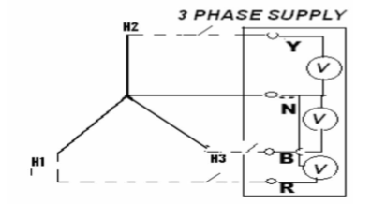
c) Procedure for the Test
1. For delta connected winding, apply 3-phase 440 V between phase to phase of a winding and measure the voltage induced in other two phases of the same winding.
2. For star winding, apply 1 phase 230 V between phase and neutral and measure the voltage induced in other two phases of the same winding.
3. Similarly all the phase should be checked with reference to other two phases

4. Winding Insulation Resistance Measurement
a) Purpose of the Test
This test reveals the condition of voids in the dielectric insulations like solid insulation in the winding due to heat or moisture, any dampness solubility in the oil, presence of any foreign objects which is having the corrosive characteristic present in the bushing.

b) Principle of the Test
If a test voltage is applied across a piece of insulation, then by measuring the resultant current and applying ohm’s law (R=E/I), the resistance of the insulation can be calculated. Effect of temperature in measurement of insulation resistance is for every 10 deg increase in temperature, half the resistance; or for every 10 deg decrease in temperature, double the resistance. For example, a 100 Gohm resistance at 20 deg becomes 25 Gohm at 40 deg. Cen.

  - HV/E+LV Shorted
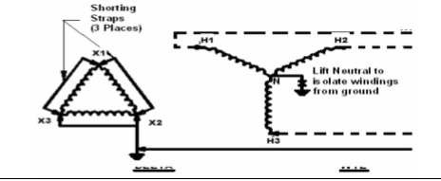

  - LV/E + HV Shorted
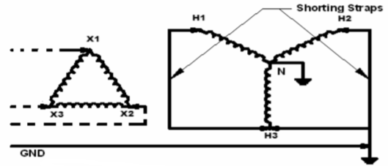

  - HV /LV + Ground Open
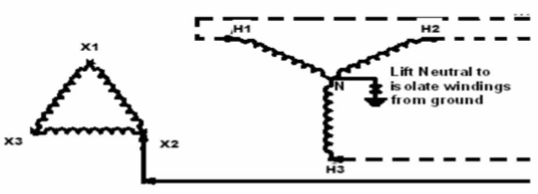
c) Procedure for the Test

1. Connect leads to HV winding and LV winding to measure IR between windings.
2. Apply 5 KV and take measurement at interval of 15 sec, 60 sec and 600 sec
3. Connect leads between winding and earth to measure IR between winding and earth.
4. Keep the other windings shorted and earthed.
5. Repeat the test.

5. Vector Group Test of Transformer

